SWE20004 Technical Software Development Semester 1 2020

Assignment 2 report

Name: Dipesh Goyal Student ID:102558284

Lab class: Friday,12:30 Tutor: Srikanth Thudmu

Due Date: Monday 4th May 2020

Date Submitted:

Assignment Title: Credit Card Validator

Program description

In your own words, describe what the application does or what
problem the application solves.

Inputs and Outputs
The inputs and outputs for this program are described in Table 1.

Table 1. Data dictionary:
Data to be stored | Sample data | Type of data | C++ type | Input method | In /  Out | Variable name
first name | “Fritz” | text: 2-20 characters | string | cin | cout | firstName
Interest amount | $1333.22 | real number | double | cin | out | amount

3. Algorithm
Program steps:
  - Flush the keyboard
  - Prompt for input
  - Enter the number
  - Check range – if too small or too big return to a.

Coding logic:

Decoding logic:

Source code:
- #include <iostream>

- using namespace std;

- //Fuction Protypes
- int total1(int array[],int arraySize); // to get sum1
- int total2(int array[],int arraySize); // to get sum2

- int main()
- {
- int array[20];
- int i;
- int temp = 0;
- int count= 0;
- int sumTotal = 0;
- int checksum= 0;

- printf("Enter The Credit Card Number Below: \n");
- for (i = 0; i < 20; i++)
- {
- cin >> temp; // storing credit card numbers
- if (temp != -1) // stores till -1.
- {
- array[i] = temp; // storing in array.
- count++;
- }
- else
- break;
- }
- cout << "The Credit Card number is: ";
- int c;
- for (c = 0; c < count; c++)
- {
- cout <<array[c]; // print credit card number that is entered
- }
- cout << "\n";

- // SUM 1
- int sum1 = total1(array,count); // function is also printing sum numbers
- cout << "Sum 1 is " << sum1 << "\n";

- // SUM 2
- int sum2 = total2(array,count); // function is also printing sum numbers
- cout << "Sum 2 is " << sum2 << "\n";

- // CheckSum
- sumTotal = sum1 + sum2;
- sumTotal = sumTotal * 9;
- checksum = sumTotal % 10;
- cout << "Check sum is " << checksum << "\n";
- cout << "The last digit of the credit card is " << array[count - 1] << "\n";
- if (array[count - 1] == checksum)
- {
- cout << "Check sum digit "<< checksum << " and the last digit " << array[count - 1] << " are the same: Valid credit card number. \n";
- }
- else
- {
- cout << "Check sum digit "<< checksum << "and the lastdigit " << array[count - 1] << " are not the same: Invalid credit card number. \n";
- }
- return 0;
- }

- int total1(int array[],int arraySize) // Function to get sum1 numbers and sum1.
- {
- int total1=0;
- int i = 0;
- int x= 0;
- int sum= 0;
- int temp[10];
- int count = 0;
- cout<< "Numbers for sum1 are ";
- for (i = arraySize - 2; i >= 0; i = i - 2)
- {
- temp[count + 1] = array[i];
- count++;
- x = array[i] * 2;
- if (x > 9)
- {
- x = x % 10;
- sum = 1 + x;
- total1 = total1 + sum;
- }
- else
- {
- total1 += array[i] * 2;
- }
- }
- for (i = count; i > 0; i--)
- {
- cout << temp[i] << " ";// printing sum1 numbers
- }
- cout << "\n";
- return total1;
- }

- int total2(int array[],int arraySize) // Function to get sum2 numbers and sum2.
- {
- int total2= 0;
- int i = 0;
- int temp[10];
- int count = 0;
- cout<< "Numbers for sum2 are ";
- for(i = arraySize - 3; i >= 0; i = i - 2)
- {
- temp[count + 1] = array[i];
- count++;
- total2 = total2 + array[i];
- }
- for (i = count; i > 0; i--) // printing sum2 numbers
- {
- cout << temp[i] << " ";
- }
- cout << "\n";
- return total2;
- }

Screenshots showing working program (Show all possible outcome):
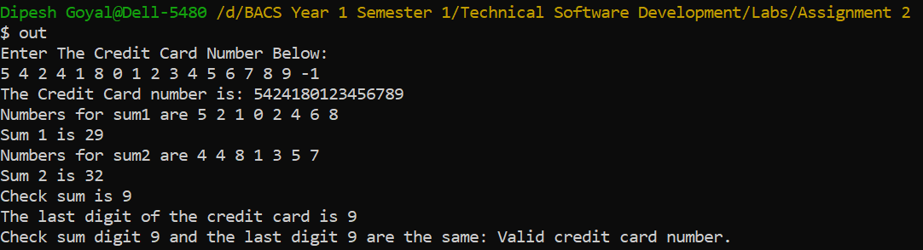
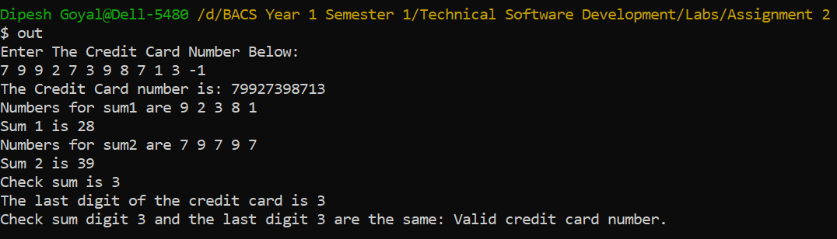
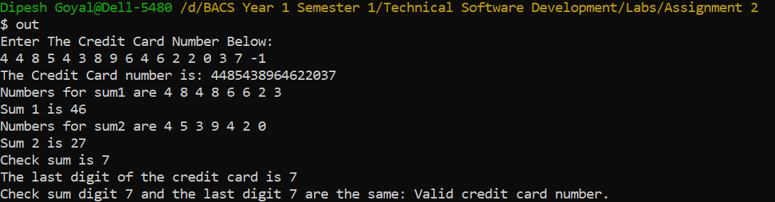
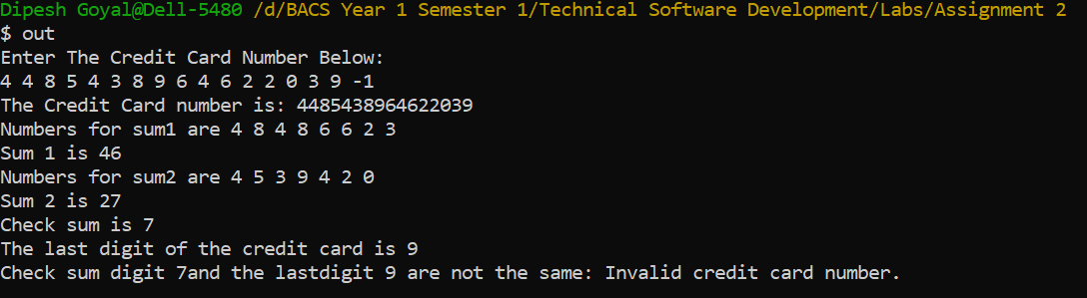

Task 5.3

Program description

Source Code
- #include <iostream>
- #include <cstdlib> //for random function library
- #include <ctime> // for srand
- using namespace std;

- //Function Prototypes
- int random(int num);
- void comment(int attempts);

- int main()
- {
- int num = random(num);
- int guess, attempts = 0;
- char answer = 'y';
- // Prompts User
- do // loop to keep running until users chose not to play.
- {
- cout << "I have a number between 1 and 1000.\n";
- cout << "Can you guess my number?\n";
- cout << "Enter a guess between 1 and 1000 : ";
- cin >> guess;
- attempts++;
- // Conditions to display message if guess is bigger or less than the number
- if (guess > num)
- {
- cout << "Too high. Try again\n";
- }
- else if (guess < num)
- {
- cout << "Too low. Try again\n";
- }
- else
- {
- // When user wins
- cout << "\nExcellent! You guessed the number!\n";
- comment(attempts);
- cout << "Would you like to play again?\n";
- cout << "Please type y or n?\n"; // Prompt if they want to play again or not
- cin >> answer;
- if(answer == 'y')
- {
- num = random(num);
- guess = 0;
- attempts = 0;
- }
- }
- } while (answer == 'y');
- return 0;
- }

- //Function 1
- int random(int num) // Function to generate random number
- {
- srand(time(NULL)); //seed random number generator
- num = rand() % 1000 + 1; // random number between 1 and 100
- return num;
- }

- //Function 2
- void comment(int attempts) // function to display comment based on number of attempts
- {
- // Condition to check number of attempts and displasy message accordingly
- if(attempts <= 10){
- cout << "Either you know the secret or you got lucky!\n";
- }
- else if(attempts == 10){
- cout << "Ahah! You know the secret!\n";
- }
- else if(attempts >= 10){
- cout << "You should be able to do better!\n";
- }
- }

Screenshots showing working program
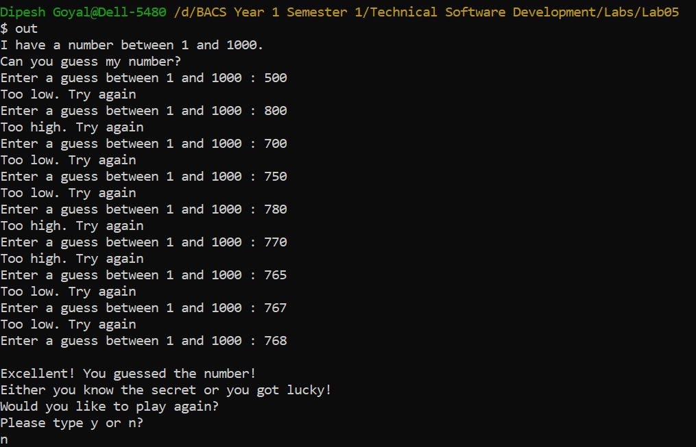

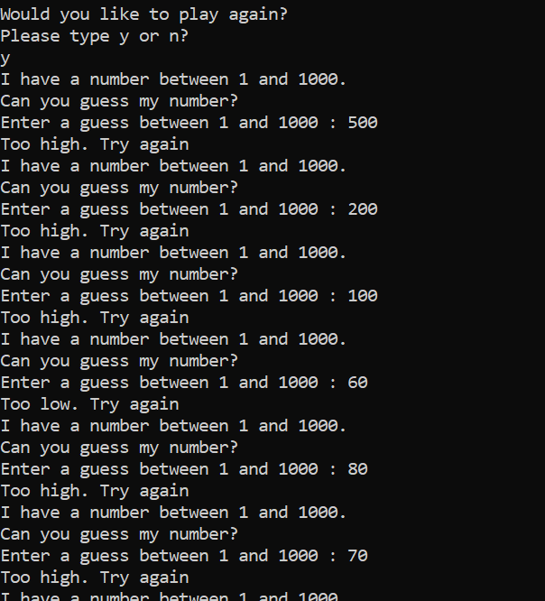

Task 5.4

Program description

Source Code

Screenshots showing working program

Task 6.3

Program description

Source Code
- #include <iostream>
- #include <string>
- #include <cstdlib>

- using namespace std;

- //Function Protypes
- void readArray(char input[], int size);
- void alphabetSort(char input[], int size);
- void frequency(char input[], int size);

- int main() //MAIN Function
- {
- char input[20]; // Array of 20 characters
- readArray(input, 20);
- alphabetSort(input, 20);
- frequency(input, 20);
- }

- void readArray(char input[], int size) //Function to store characters in array and check for duplicate and letters
- {
- int i, c;
- char m;

- for (i = 0; i < size; i++)
- {
- cout << "Enter character \n";
- fflush(stdin);
- cin >> m;
- if (tolower(m) < 'a' || tolower(m) > 'z') // Check if alphabet or not
- {
- cout << m << " is not an alphabet\n";
- i--;
- }
- else
- input[i] = m;
- for (c = 0; c < i; c++)
- {

- if (input[c] == input[i]) // if matches it is a duplicate
- {
- cout << input[c] << " is a duplicate letter.\n";
- c = i;
- }
- }
- }
- cout << "\n";
- cout << "The original array is:\n"; // Prints the original array
- for (i = 0; i < size; i++)
- {
- cout << input[i];
- }

- }

- void alphabetSort(char input[], int size) // Function to sort the array in alphabatical order
- {
- int i = 0, m = 0;
- char L;
- for (i = 0; i < size; i++)
- {
- for (m = i + 1; m < size; m++)
- {
- if (tolower(input[i]) > tolower(input[m]))
- {
- L = input[i];
- input[i] = input[m];
- input[m] = L;
- }
- }
- }
- cout << "\nThe sorted array is:\n"; // Prints the sorted array
- for (i = 0; i < size; i++)
- {
- cout << input[i];
- }
- }

- void frequency(char input[], int size) // Frequent Letter function
- {
- char mode[20];
- int count=0, Max=0, a=0, fre[20], i, j;

- for(i=0; i<size; i++)
- {
- count =1;
- for(j=i+1; j<size; j++)
- {
- if(input[i] == input[j])
- count++;
- else
- break;
- }
- mode[a]= input[i];
- fre[a]= count;
- if(Max<count)
- Max = count;
- a++;
- i = j-1;
- }
- for(i=0; i<size; i++)
- {
- if(Max == 1){ // If the max is 1 means the all occurences only happened once.
- cout << "\nAll characters are entered only one time.\n";
- break;
- }else if(Max == size){ // if max is equal to size means all characters are different
- cout << "\nAll characters are the same.\n";
- break;
- }else if(Max == fre[i]){ // to print occurences more than 1
- cout << "\nThe mode is '" << mode[i] << "' and it is occuring " << fre[i] << " times.\n";
- break;
- }
- }
- }

Screenshots showing working program

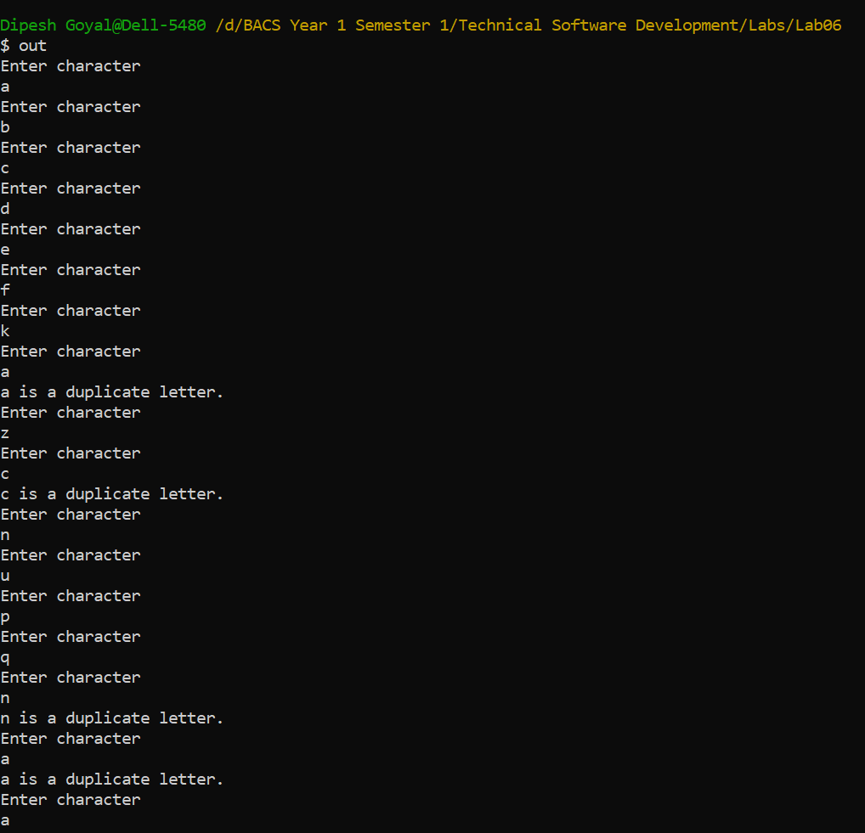
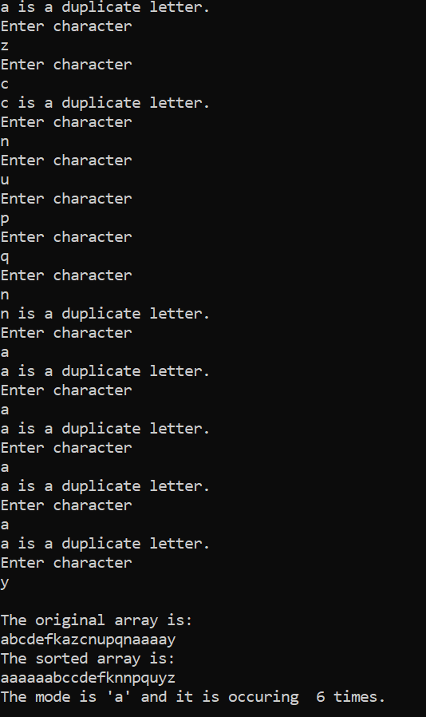
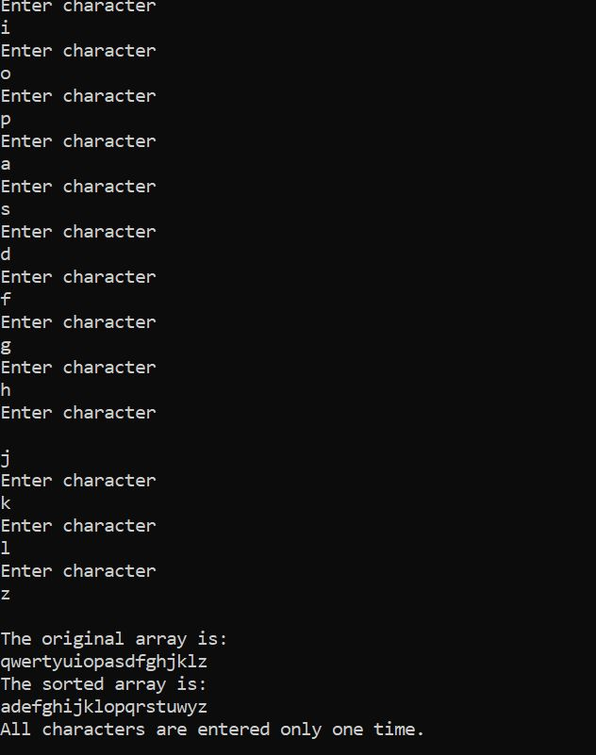

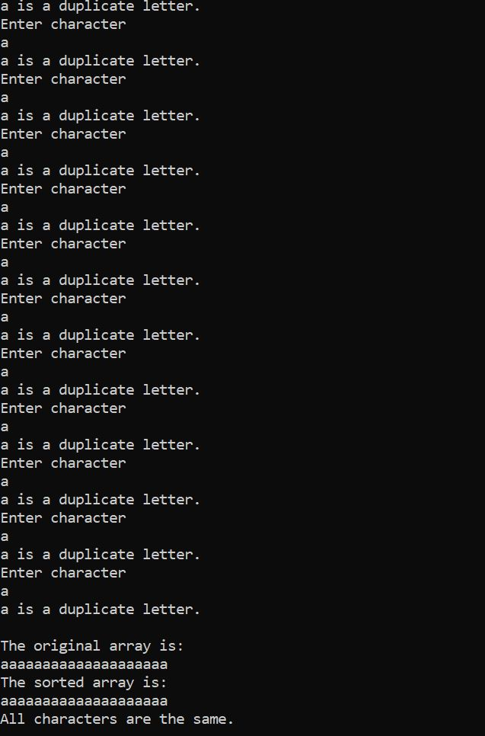

Task 6.4

Program description

Source Code
- #include <iostream>
- #include <iomanip>
- #include <ctime>

- using namespace std;

- int Random(); //Function Prototype

- int main()
- {
- int i;
- int j;
- int sum =0;
- int dice1;
- int dice2;
- int total = 0;
- const int columnSize = 6;
- const int rowSize = 6;
- int diagonal[6];
- int faces[columnSize][rowSize]; // two dimensional array
- for (int row = 0; row < 6; row++)
- {
- for (int column = 0; column < 6; column++)
- faces[row][column] = 0;
- }
- for (int i = 0; i < 50000; i++) // runs 50000 times
- {
- dice1 = Random();
- dice2 = Random();

- faces[dice1][dice2]++;
- faces[6][6] = faces[dice1][dice2];
- }
- cout<< "\n-----\t-----\t-----\t-----\t-----\t-----";
- for(int row = 0; row < 6; row++)
- {

- cout<<endl;
- cout<< ":";
- for(int column = 0; column < 6; column++)
- {
- cout<< faces[column][row] << " :" << "\t";

- }
- cout<< "\n-----\t-----\t-----\t-----\t-----\t-----";
- }
- cout << "\n";
- cout << "\nThe sum of the diagonal element is \n";
- for (i=0;i < rowSize;++i)
- {
- for (j=0;j < columnSize;++j)
- {
- if (i==j)
- cout << "\n" << faces[i][j] ;
- }
- }
- cout << " +\n";
- cout << "-------\n";
- for(i=0;i<6;i++)
- {
- for(j=0;j<6;j++)
- {
- if(i==j)
- sum=sum+faces[i][j]; // total of diagonals
- }
- }
- cout << sum << "\n";
- if(sum > 8350){
- cout << sum << " is greater than 8350, the player wins the game !!!\n";
- }else if( sum < 8350){
- cout << sum << " is less than 8350, the player lost the game !!!\n";
- }

- return 0;

- }

- int Random()
- {
- int number;
- static int flag = 1; //static so only meets the condition once.

- if (flag == 1)
- {
- srand(time(0));
- flag = 0;
- }
- number = rand() % 6;
- return number;
- }

Screenshots showing working program
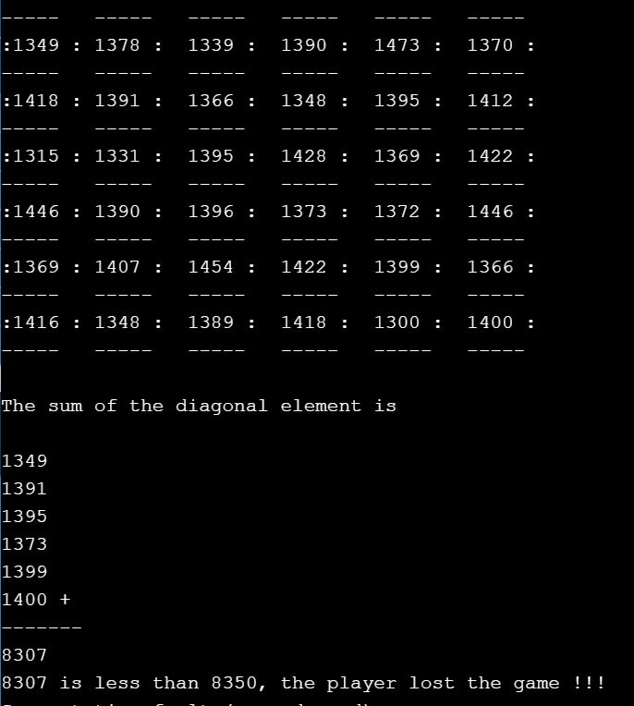
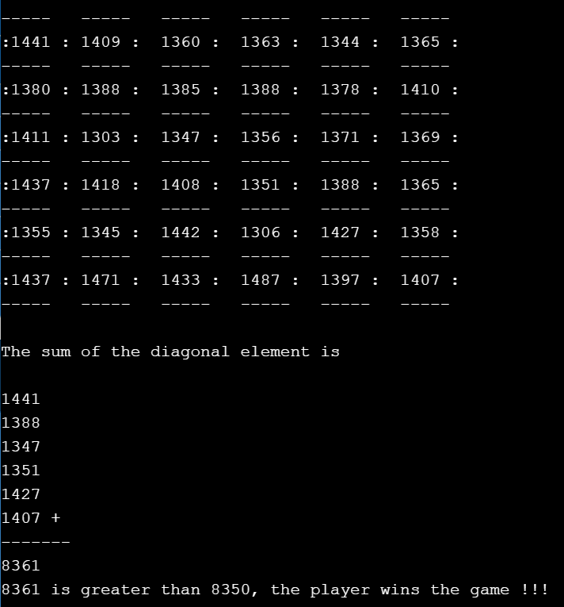

Task 7.1

Program description

Source Code
- #include <iostream>
- #include <fstream>
- #include <iomanip>

- using namespace std;

- int main()
- {
- string filename = "price.dat";
- int descrip;
- double price = 0;
- int count = 0;
- double total = 0;
- float max = 0;
- double min = 10000000; // for condition to satisfy
- int i;

- ifstream inFile;

- inFile.open(filename.c_str());

- if (inFile.fail()) // if file doesnt open successfully
- {
- cout << "The File was not opened successfully\n";
- cout << "Please check that the file currently exists\n";
- return 0;
- }
- inFile >> count; // storing number of records in count

- for (i = 0; i < count; i++) // for loop to get the total, min and max
- {
- inFile >> descrip >> price;
- total = total + price; // total for average
- if (max < price) // condition for max
- max = price;
- if (min > price) // condition for min
- min = price;
- }
- inFile.close(); // file close

- // display output in terminal
- cout << "Number of price readings: " << count << "\n";
- cout << "Maximum price: " << setprecision(2) << fixed << max << "\n";
- cout << "Minimum price: " << min << "\n";
- cout << "Average price: " << total / count << "\n";

- ofstream outFile;
- //write output to file.
- outFile.open("output.dat");
- outFile << "Number of price readings: " << count << "\n";
- outFile << "Maximum price: " << setprecision(2) << fixed << max << "\n";
- outFile << "Minimum price: " << min << "\n";
- outFile << "Average price: " << total / count << "\n";

- outFile.close(); // close output file.

- return 0;
- }

Screenshots showing working program
